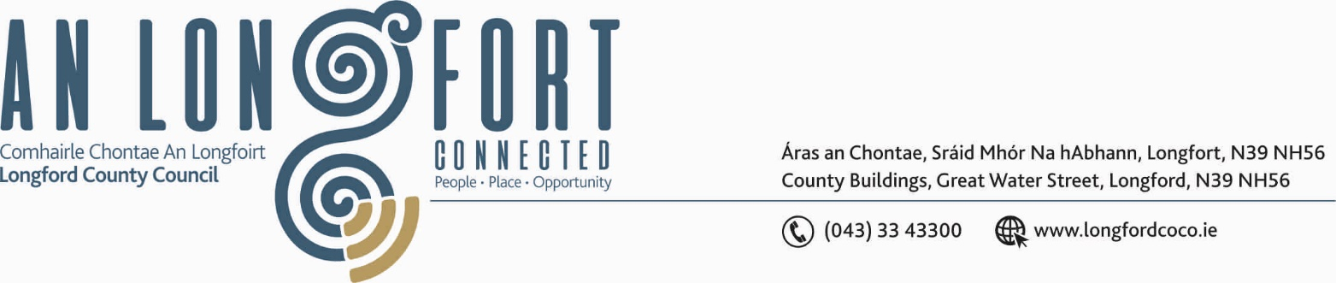

BALLYMAHON MUNICIPAL DISTRICT

17th January 2020.

To: Each Member of Ballymahon Municipal District.

Dear Member,

You are requested to attend Meeting of Ballymahon Municipal District to be held in Ballymahon Community Library, on Thursday, 23rd January 2020 at
4.00 p.m. to transact business, as set out on the Agenda hereunder.

Yours sincerely,
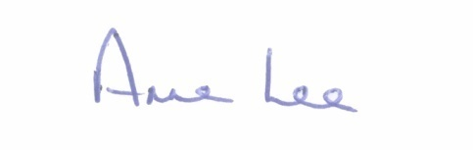

_______________
Anne Lee,
Meetings Administrator.

AGENDA

Prayer before meeting.

1. Confirmation of Minutes of Ballymahon Municipal District Meetings held on the 9th December 2019 - copy enclosed.

2. Matters arising from Minutes.

3. Declaration of Interest by Members.

4. Management Report - enclosed.

5. Consideration and adoption of Draft Municipal District Report for inclusion in
Longford County Council 2019 Annual Report – enclosed.

6. Consideration of Adoption of Part 8 Report (Planning and Development Act 2000 (as amended) and Planning and Development Regulations 2001 (as amended) in respect of proposed alterations to external elevations, rear carpark arrangement and site entrance at Main Street, Edgeworthstown, Co. Longford.
- details enclosed.

7. Notices of Motions submitted by Councillors, as listed hereunder –

Councillor Gerard Farrell.

That Longford County Council supplies extra lighting at the bottom of the Village at Newtowncashel, as it is very dark near the GAA Pitch.”

“That Longford County Council widen the road by 1 meter at the junction at
Carradogor, Newtowncashel to allow for cars and heavy machinery to pass safely.”

Councillor Pat O’Toole.

“I call on Longford County Council to establish if a disabled parking space can be provided at the Primary Care Centre (G P’s Surgery) Lower Main Street Ballymahon.”



